Ques 1:- Retrieve the total number of orders placed ?

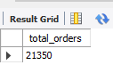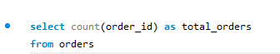

Ans –

Ques 2 :- Calculate the total revenue generated from pizza sales ?

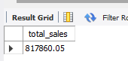 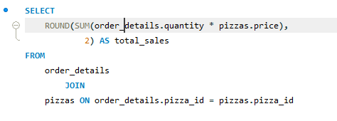

Ans –

Ques 3:- Identify the highest-priced pizza ?

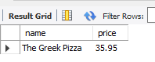 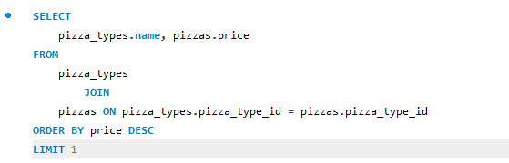

Ans –

Ques 4:-Identify the most common pizza size ordered ?

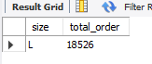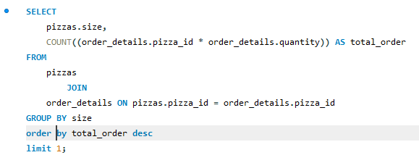

Ans-

Ques. 5:- List the top 5 most ordered pizza types along with their quantities ?

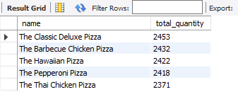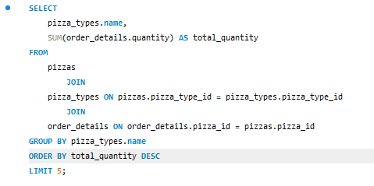

Ans –

Ques. 6:- Join the necessary tables to find the total quantity of each pizza category ordered ?

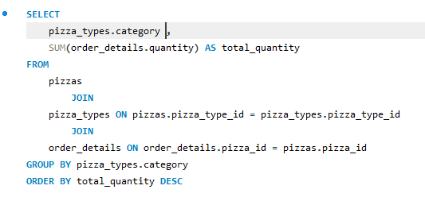

Ans - 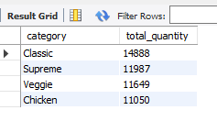

Ques. 7:- Determine the distribution of orders by hour of the day ?

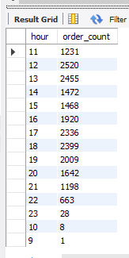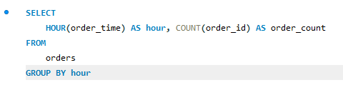

Ans-

Ques. 8:- Join relevant tables to find the category-wise distribution of pizzas ?

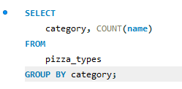

Ans - 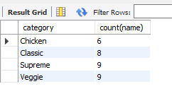

Ques. 9:- Group the orders by date and calculate the average number of pizzas ordered per day ?

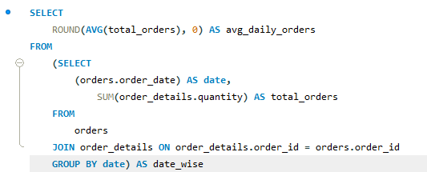

Ans - 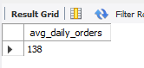

Ques. 10:- Determine the top 3 most ordered pizza types based on revenue ? 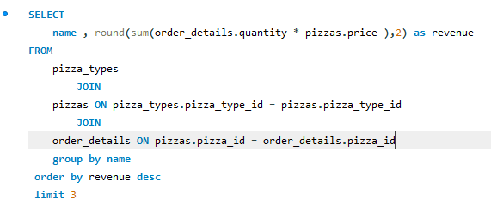

Ans - 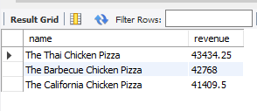

Ques. 11:- Calculate the percentage contribution of each pizza type to total revenue ?

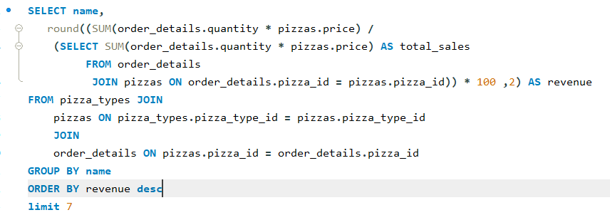

Ans - 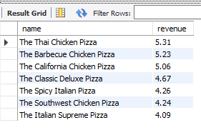

Ques. 12:- Analyze the cumulative revenue generated over time ?

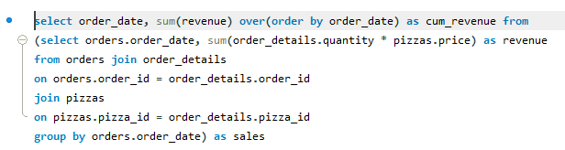

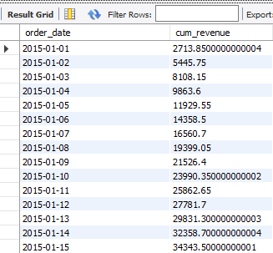Ans -

Ques. 13:- Calculate the percentage contribution of each pizza category to total revenue ?

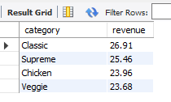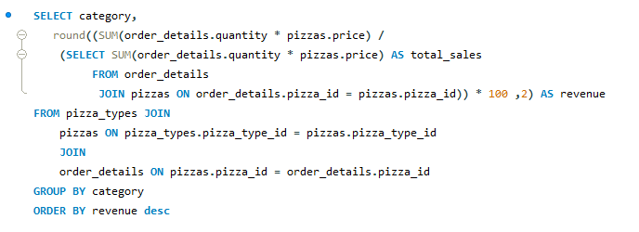

Ans –

Ques. 14:-Determine the top 3 most ordered pizza types based on revenue for each pizza category ?

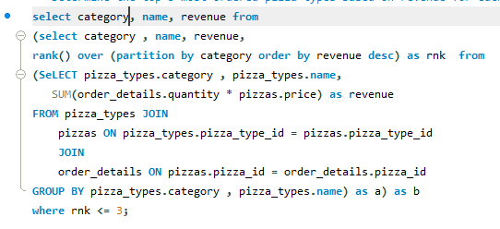

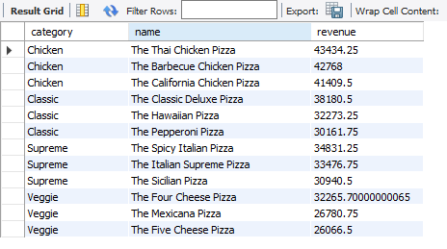Ans -

**CONCLUSON**

* Classic pizzas are the biggest contributor in revenue generation.
* The classic dulex pizza is the best seller but Thai chicken Pizza is biggest individual contributor to revenue generation
* In morning (12:00 – 14:00) are the busiest hours and in evening (16:00 – 19:00) are the busiest hours with maximum pizza sales
* Sale total to average daily sale of 138 pizzas
* ( L ) is the most orders size among all pizza sizes.